# **PIZZA SALES PROBLEM STATEMENT & QUERY REPORT**

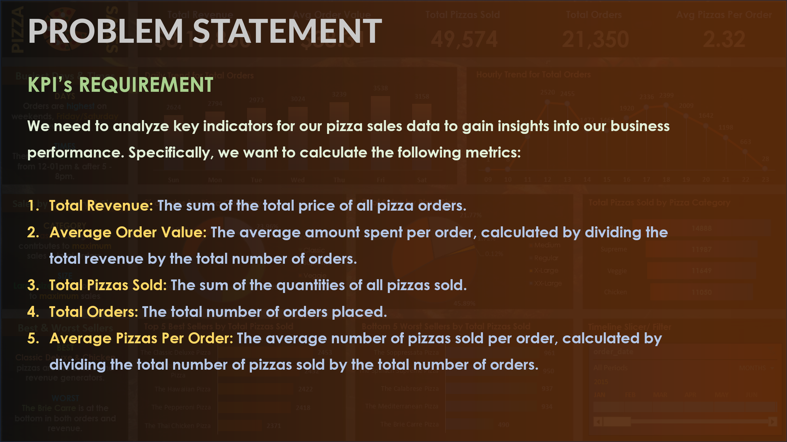

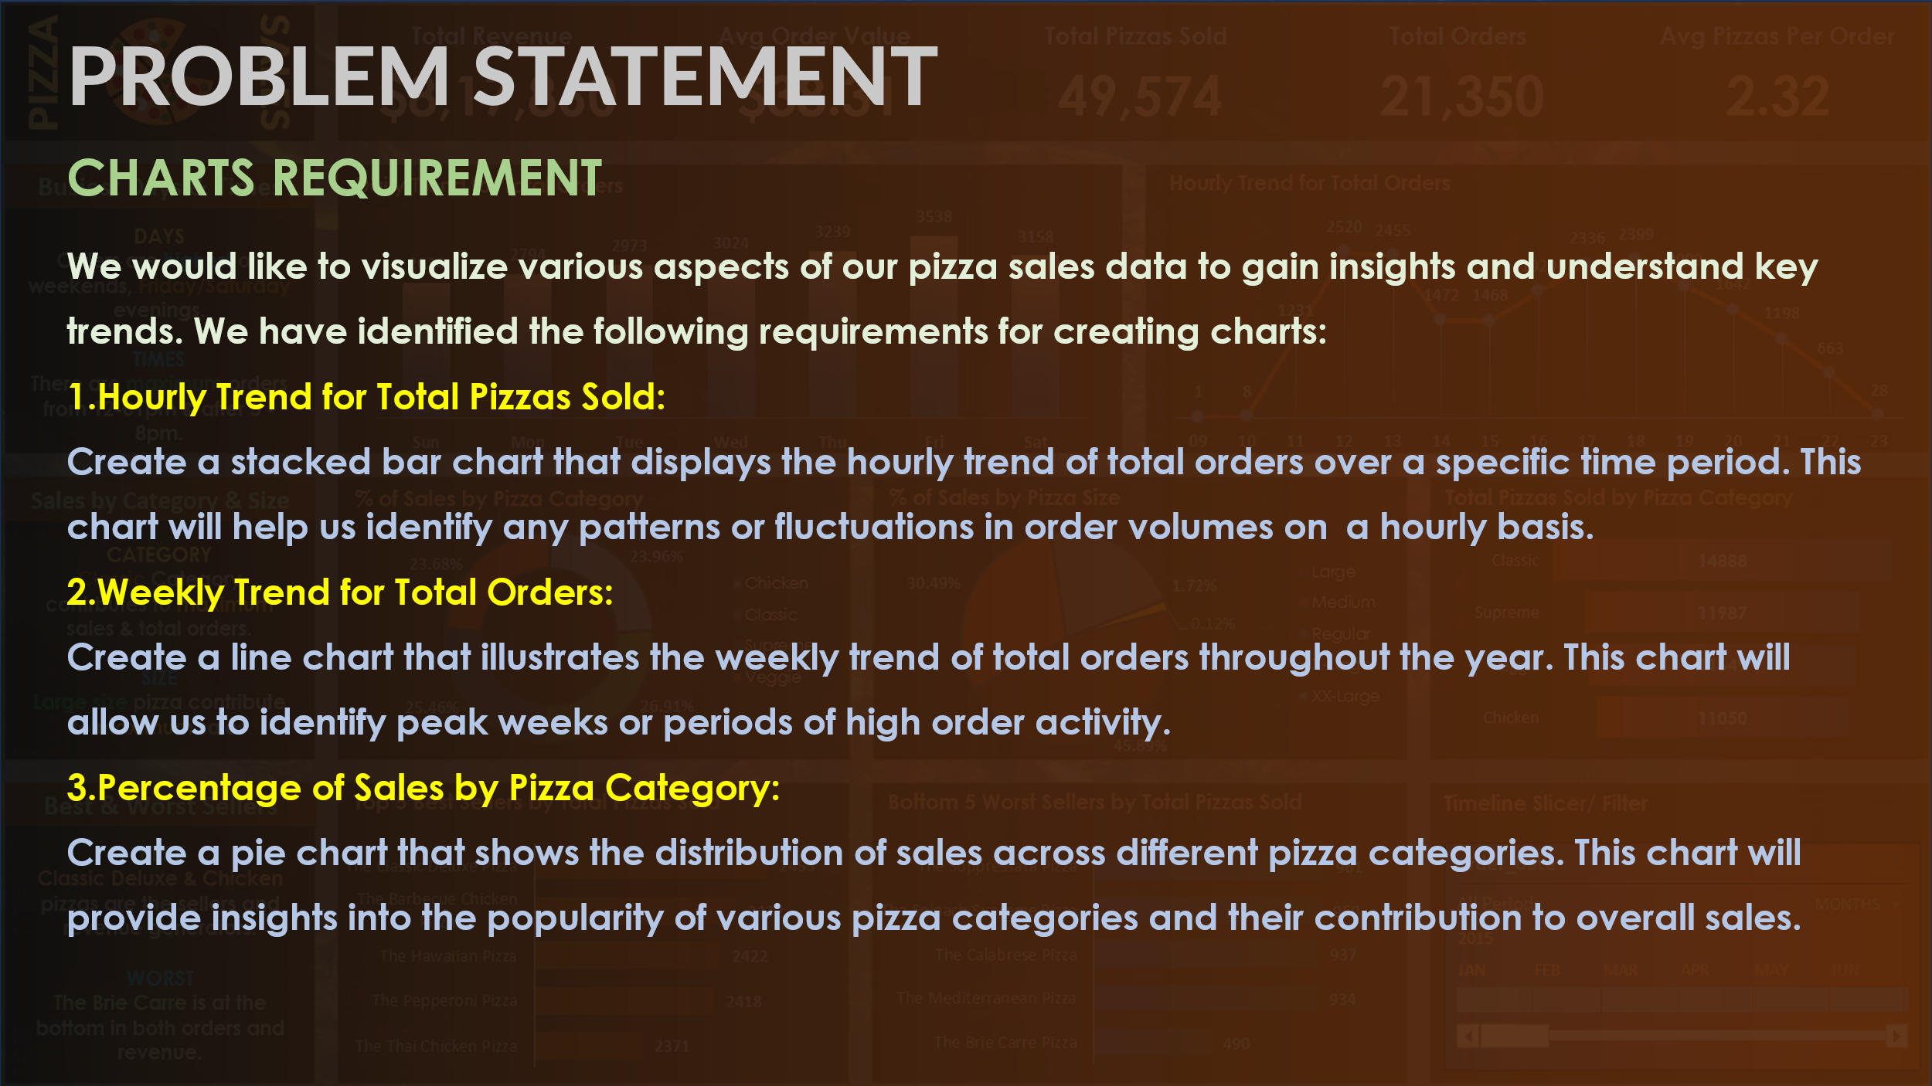

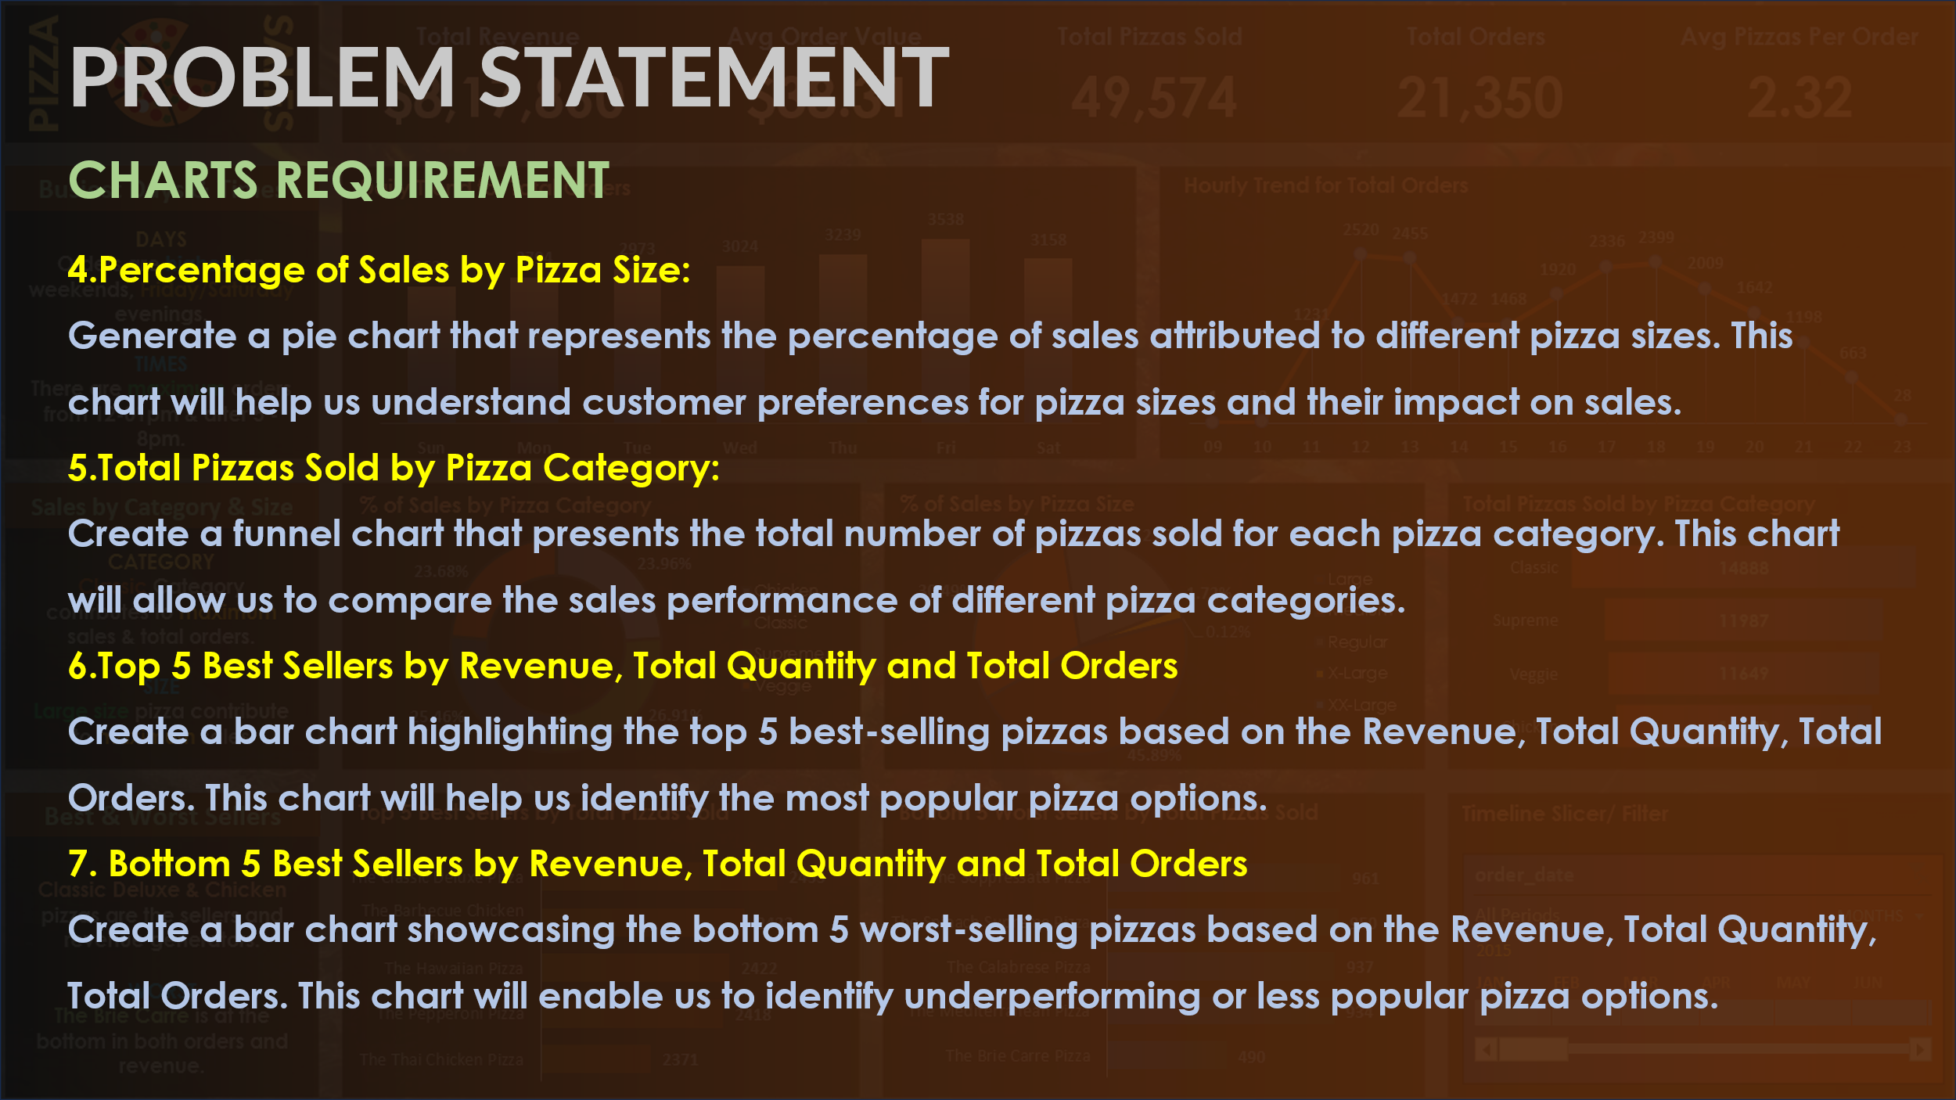

**A )KPI REQUIREMNETS – KEY PERFORMANCE INDICATOR**

1. **Total Revenue**

SELECT SUM(total_price) AS Total_Revenue FROM pizza_sales

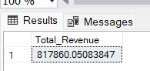

1. **Average Order Value**

SELECT SUM(total_price)/COUNT(DISTINCT order_id) AS Avg_order_Value FROM pizza_sales

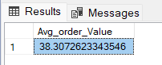

1. **Total Pizza Sold**

SELECT SUM(quantity) AS Total_Pizza_Sold FROM pizza_sales

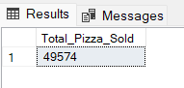

1. **Total Orders**

SELECT COUNT(DISTINCT order_id) AS Total_Orders FROM pizza_sales

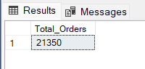

1. **Average Pizzas Per Order**

SELECT CAST(CAST(SUM(quantity) AS DECIMAL (10,2)) / CAST(COUNT(DISTINCT order_id) AS DECIMAL(10,2)) AS DECIMAL(10,2)) as Avg_Pizzas_Per_Order FROM pizza_sales

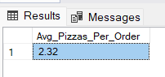

1. **Hourly Trend for Total Pizza Sold**

SELECT DATEPART(HOUR, order_time) as order_hour, SUM(quantity) as Total_Pizzas_sold

FROM pizza_sales

GROUP BY DATEPART(HOUR, order_time)

ORDER BY DATEPART(HOUR, order_time)

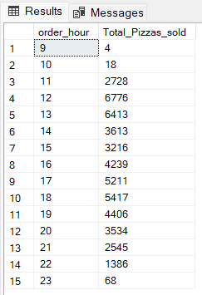

1. **Weekly Trend for Orders**

SELECT DATEPART(ISO_WEEK, order_date) as week_number,

YEAR(order_date) AS Order_year,

COUNT(DISTINCT order_id)AS Total_orders

FROM pizza_sales

GROUP BY DATEPART(ISO_WEEK, order_date), YEAR(order_date)

ORDER BY DATEPART(ISO_WEEK, order_date), YEAR(order_date)

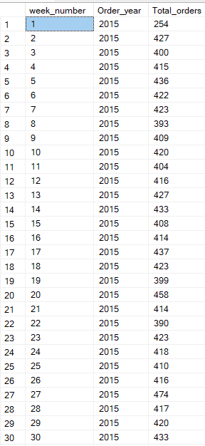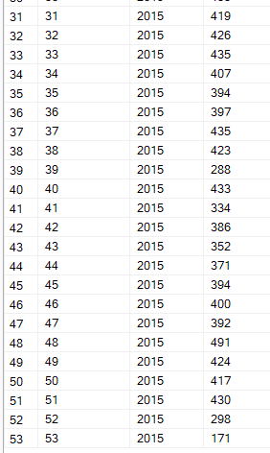

1. **% Total Pizzas Sold by Pizza category**

SELECT pizza_category, sum(total_price)* 100 / (SELECT sum(total_price) from pizza_sales WHERE MONTH(order_date) = 1) AS PCT

from pizza_sales WHERE MONTH(order_date) = 1

GROUP BY pizza_category

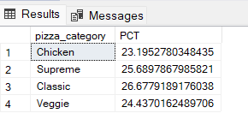

1. **Percentage of Sale by Pizza Size:**

SELECT pizza_size, sum(total_price)* 100 / (SELECT sum(total_price) from pizza_sales WHERE MONTH(order_date) = 1) AS PCT

from pizza_sales

WHERE MONTH(order_date) = 1

GROUP BY pizza_size

ORDER BY PCT DESC

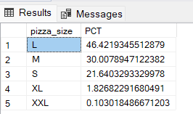

1. TOP 5 pizza by Revenue

SELECT TOP 5 pizza_name, SUM(total_price) AS Total_Revenue FROM pizza_sales

GROUP BY pizza_name

ORDER BY Total_Revenue DESC

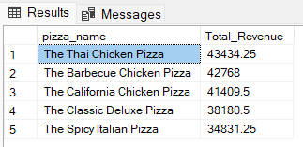

1. Bottom 5 Pizza by Revenue

SELECT TOP 5 pizza_name, SUM(total_price) AS Total_Revenue FROM pizza_sales

GROUP BY pizza_name

ORDER BY Total_Revenue ASC

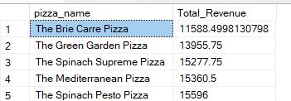

1. Top 5 pizza by Quantity

SELECT TOP 5 pizza_name, SUM(quantity) AS Total_Quantity FROM pizza_sales

GROUP BY pizza_name

ORDER BY Total_Quantity DESC

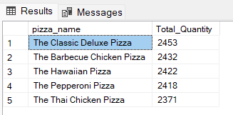

1. Bottom 5 Pizza by quantity

SELECT TOP 5 pizza_name, SUM(quantity) AS Total_Quantity FROM pizza_sales

GROUP BY pizza_name

ORDER BY Total_Quantity ASC

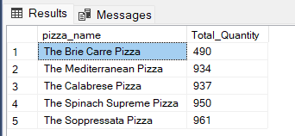

1. Top 5 pizzas by Total Orders

SELECT TOP 5 pizza_name, COUNT(DISTINCT order_id) AS Total_Orders FROM pizza_sales

GROUP BY pizza_name

ORDER BY Total_Orders DESC

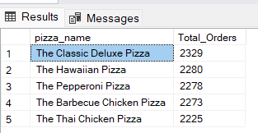

1. Bottom 5 pizza by Total orders

SELECT TOP 5 pizza_name, COUNT(DISTINCT order_id) AS Total_Orders FROM pizza_sales

GROUP BY pizza_name

ORDER BY Total_Orders ASC

